CLOUD SERVERLESS LAB-2

Name: K.Nitin reddy

Id:2000030510

Sec:13

Build a Static web hosting on AWS S3 bucket with name KLUNIVERSITY by creating bucket policy for grant public read access

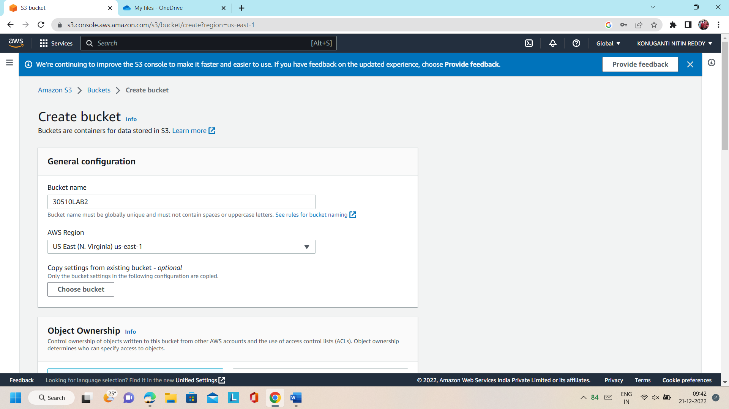

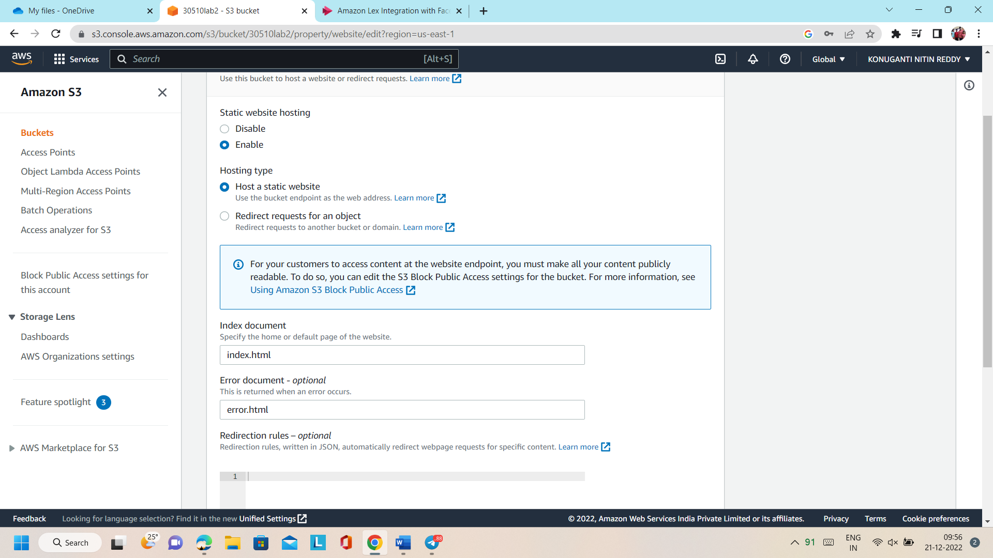

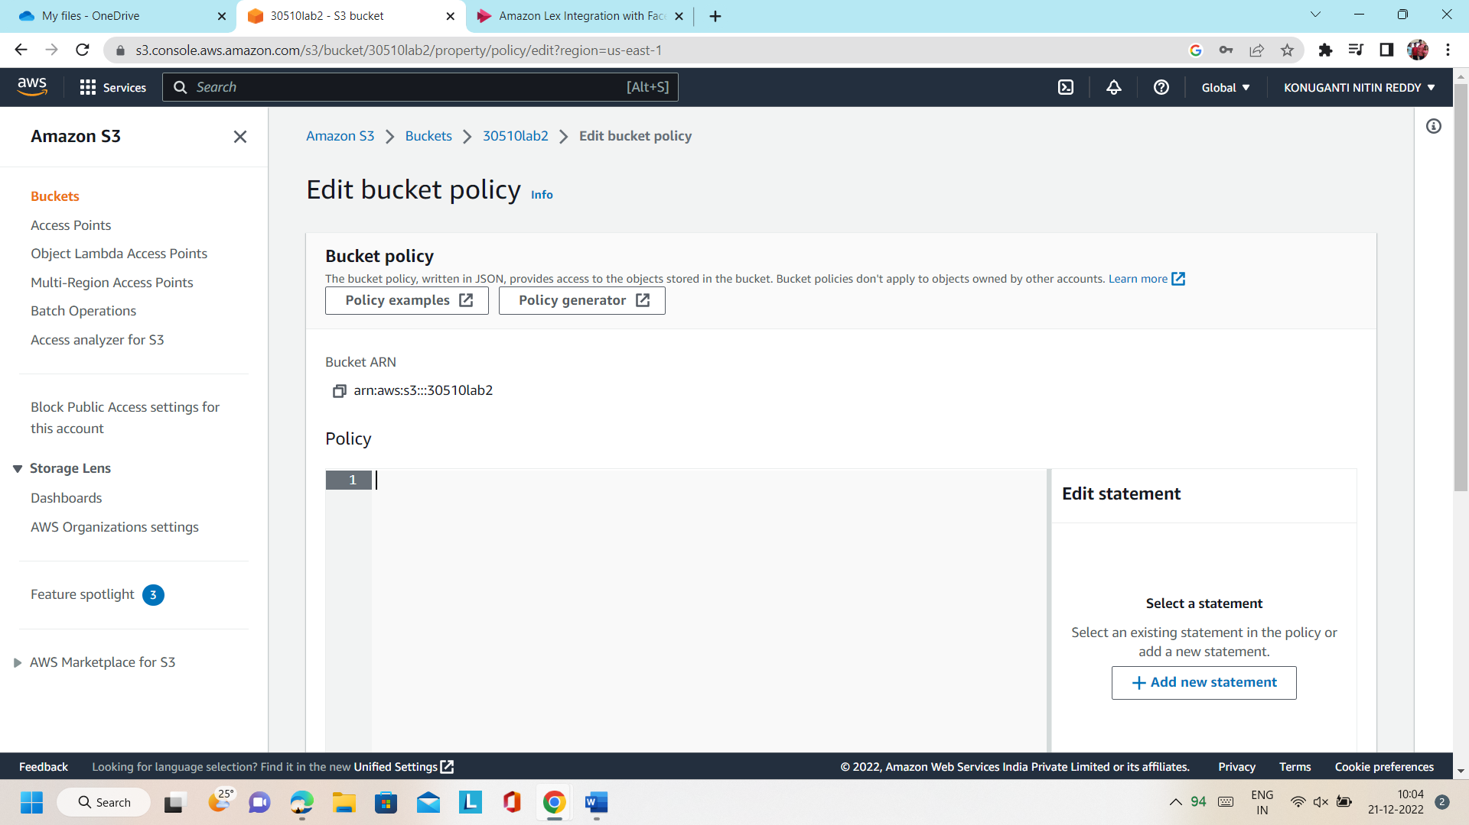

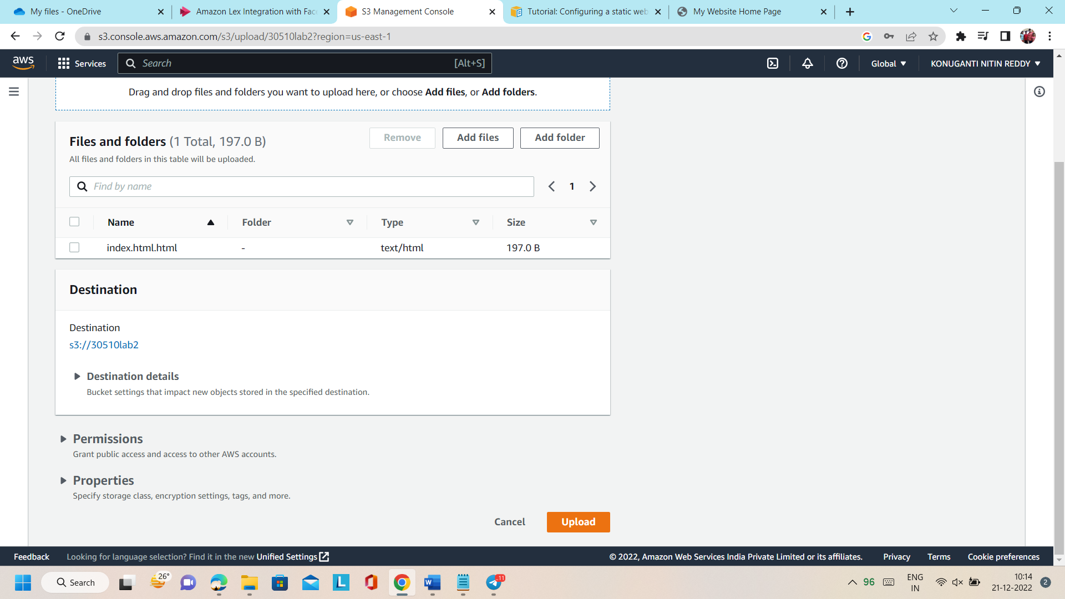

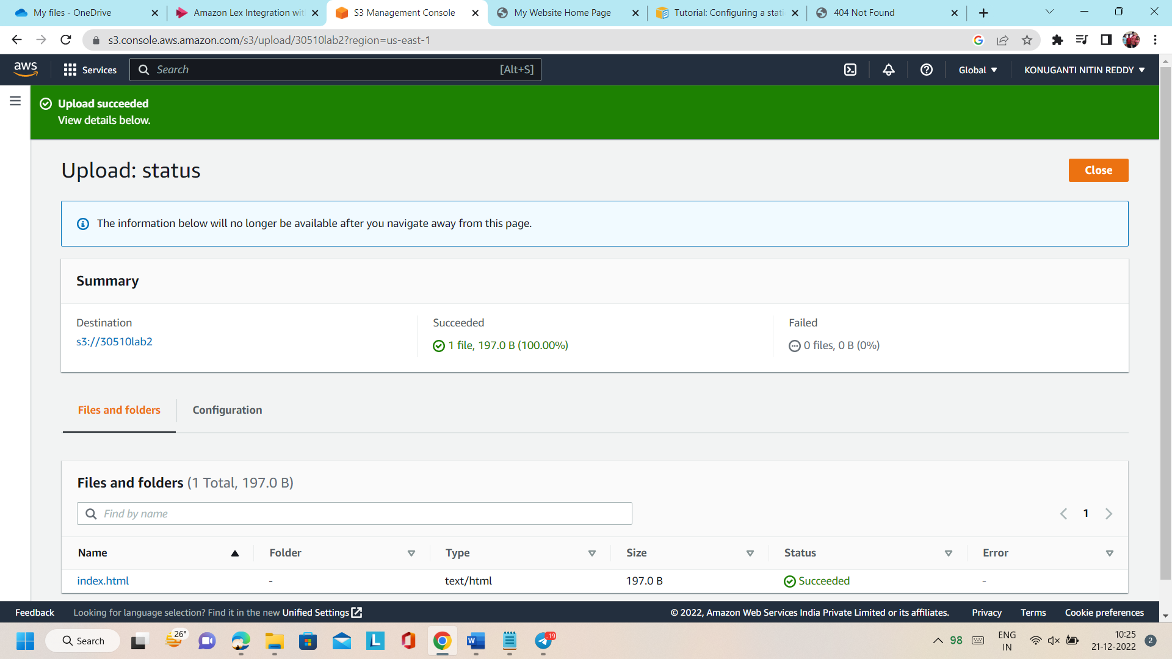

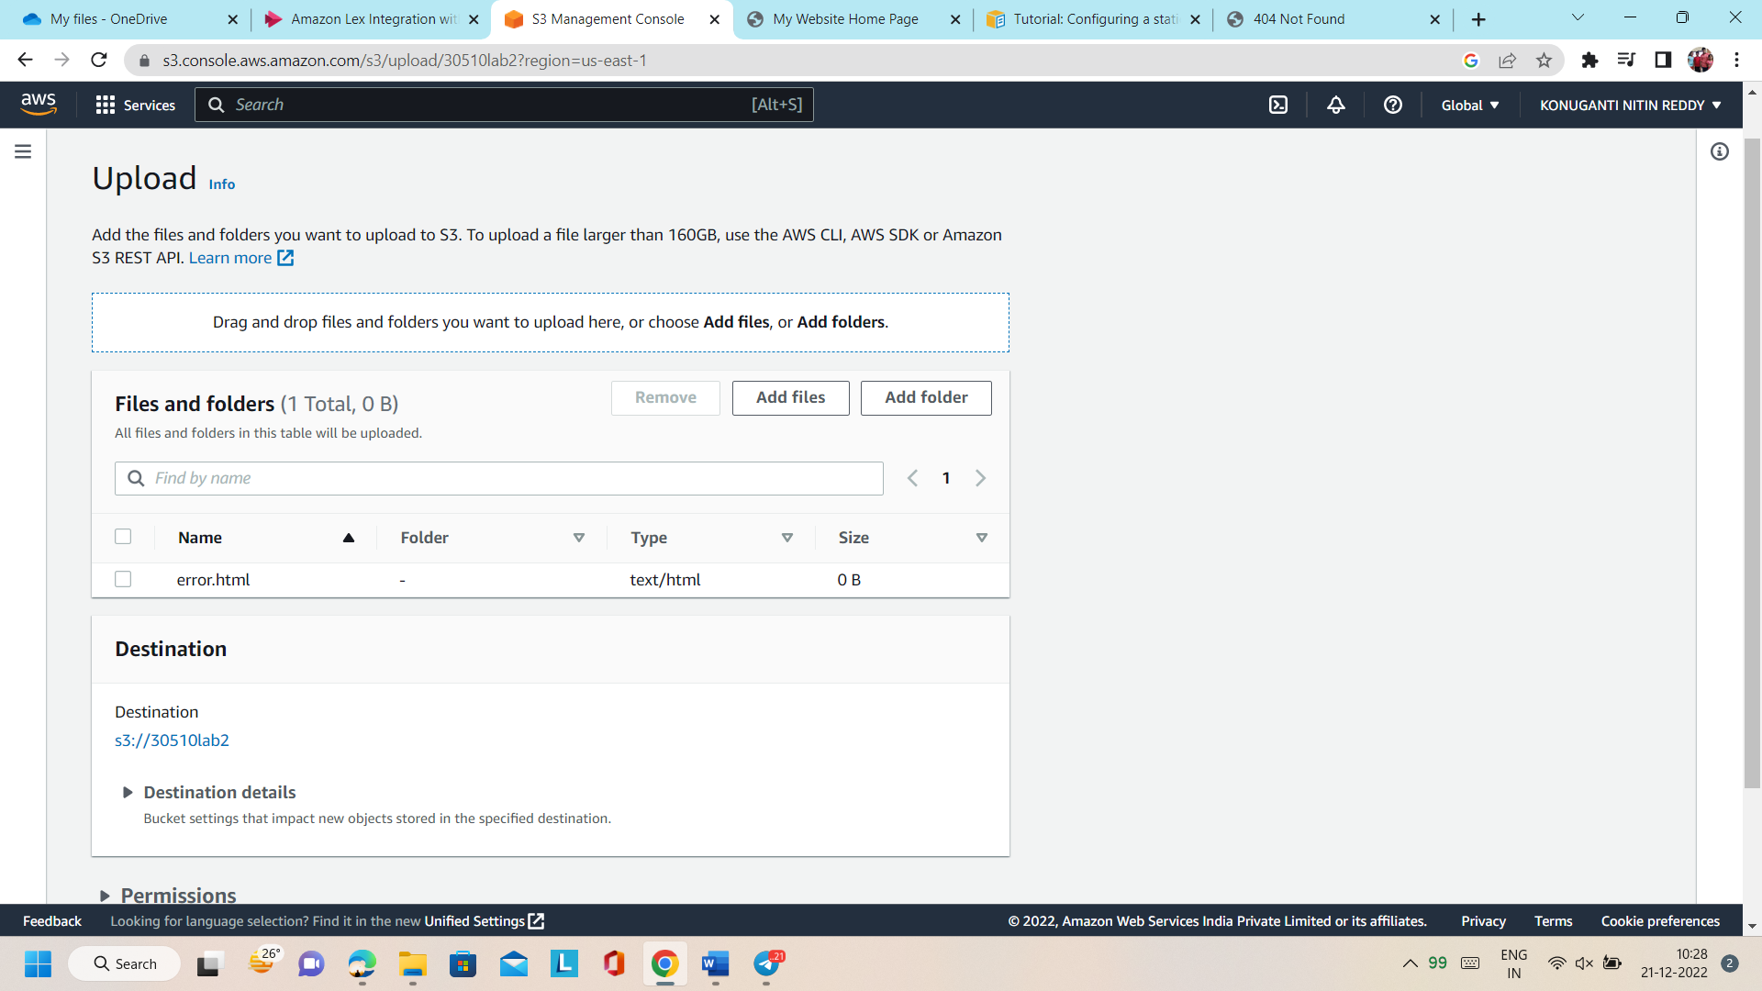

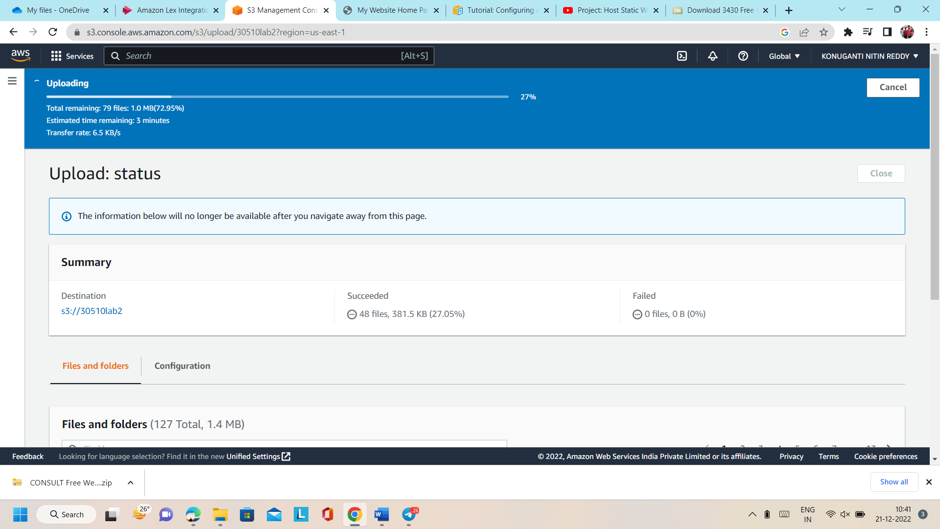

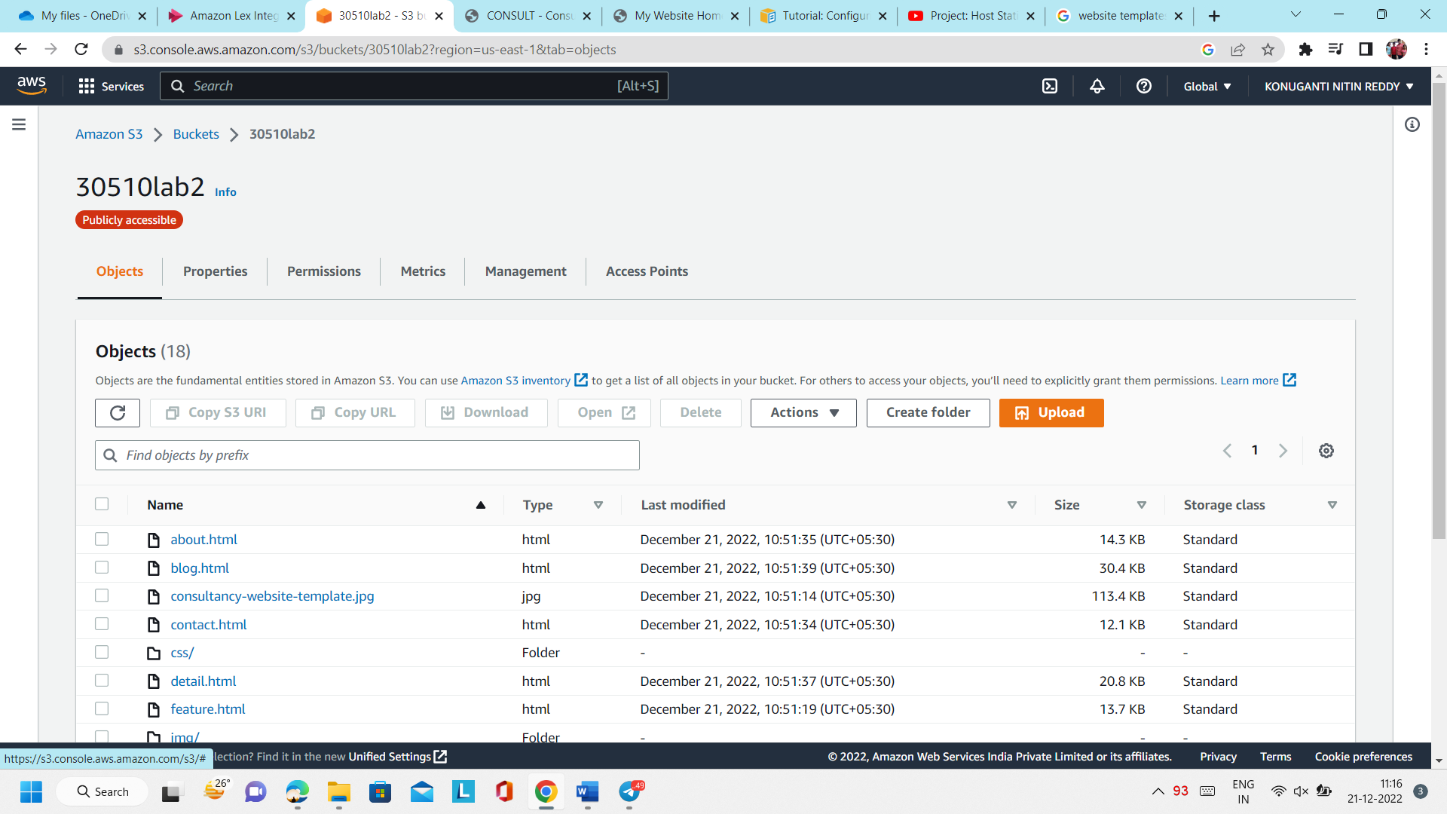

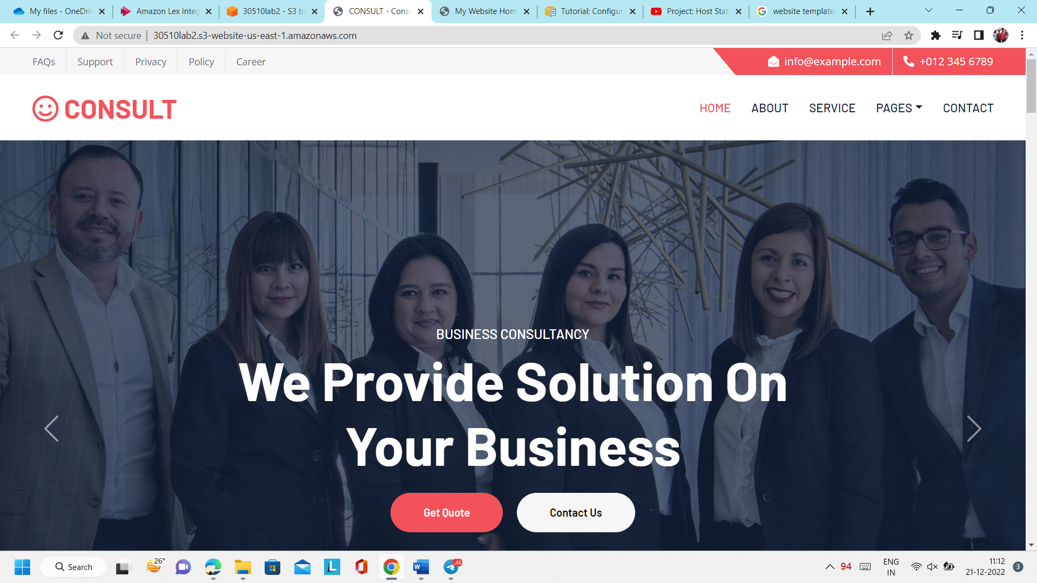

http://30510lab2.s3-website-us-east-1.amazonaws.com/